# CIT225 Lab Virtual Machine.

Overview:

Please do not buy any additional software to use this Lab Virtual Machine (VM). All the needed software can be downloaded and used for free. Or there are other ways to get you up and running.

A preconfigured Lab VM image has been created to help with this course. In order to complete CIT-225, you will need to download and run the virtual machine below. Do not try to assemble your own VM. This image has files and scripts that are required for this course.

**Last minute change. Due to issues with getting the VM image to download, please use the link in the syllabus.**

Hardware/Software:

64bit: You will need a 64bit processor. If you are running anything Windows 8 or better, you should be ok. The image will de-compress to about 18G, but plan on 25G free to hold everything.

BIOS: There are some computers that you have to turn on a the VM option on the processor inside the BIOS. If you get errors on VM startup, look into this for your computer.

Unzip: There are many utilities that can decompress (unzip) this downloaded VM Image. Windows has one, **but don’t use it**. As it will corrupt the extracted file. Use the WinRar utility, it can decompress this file. Again, it is free to use.

Additional Software:

Virtual Box: This option is completely free and will run forever.

<https://www.virtualbox.org/wiki/Downloads>

## Passwords:

There are many things running on this VM. The passwords to access these are below. While on this server, most things will be done with a Graphical Using Interface (GUI) programs. GUI Tools are available, like SQL Developer for Oracle The VM has all that you need to succeed. Below are the username/passwords for each component in the VM.

OS:

student/cangetin

root/cangetin

Oracle DB:

student/student

MySQL DB:

student/student for database studentDB

## Getting the VM Running

After you have downloaded the VM, Virtual Box (VBx) and extracted the file, you can proceed with these steps. Do not using Windows Extract. Use WinRar or 7zip. In these steps you will add the VM to VBx and start the VM. If successful, you will be presented with a login window. Other than the extract tool, these steps will work for Windows and Macs.

1. Download Virtual Box (VBx) and Install
   1. The latest version will work.
2. Extract the FedoreImageWindows_XXXXXXXX.zip
   1. Do not using Windows Extract. Use WinRar or 7zip.
   2. Do not extract inside OneDrive
3. Add the virtual disk file to VBx.
   1. Menu | Machine | New
   2. Give the machine a name: CIT225 VM
      1. Type: Linux
      2. Version: Fedora 64 Bit
         1. If you do not see this 64 Bit option, then you need to check that your computer is 64 bit, the OS is 64bit and that the VM BIOS option is on.
         2. Enabling this BOIS option is different for each laptop. Google your laptop and they will show you how to turn it on. I cannot help you with this as there are too many to support.
   3. Memory Size
      1. 4096 MB
      2. After you get it running, I have a document that can decrease the memory down to 2G. This will help with performance issues for computer that only have 4GB ram.
   4. Hard Disk
      1. Radio: Use existing virtual disk file
      2. Navigate to your extract location and find the “Virtual Box Machine Definition”
      3. It’s a Blue Box Icon and your extract path will not be the same as the image below.
      4. 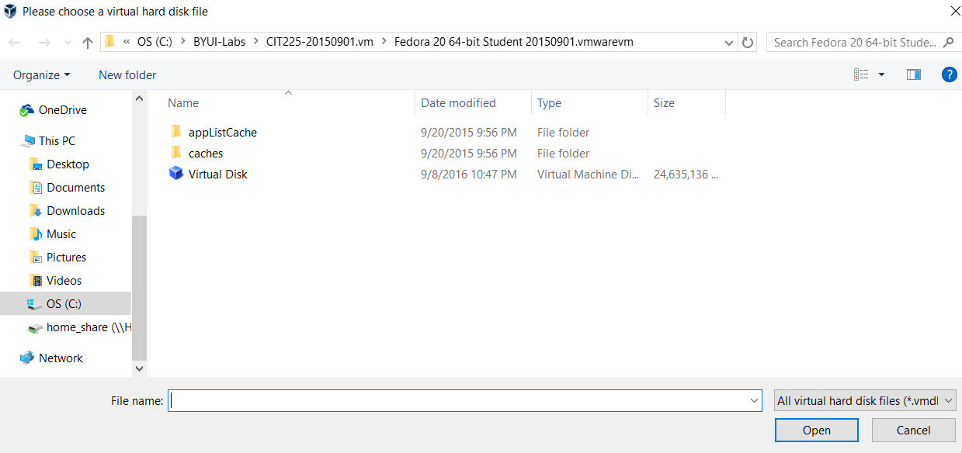
   5. Select Virtual Disk file… Press Open… Then Create on the next screen
   6. You should see a screen like the following
   7. 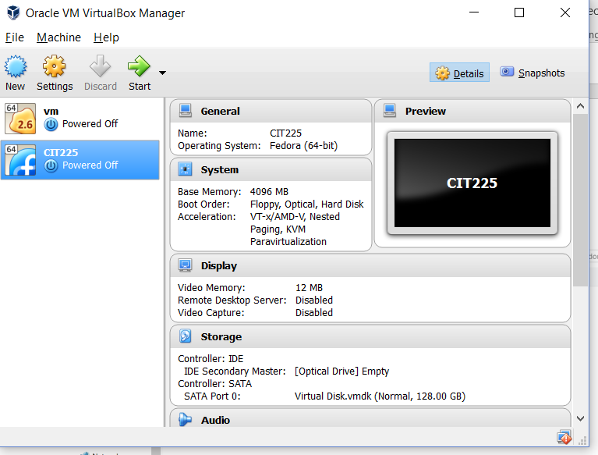
4. Press Start and you should see the VM start to boot up
5. Depending on your computer resources it may take a few minutes.
6. 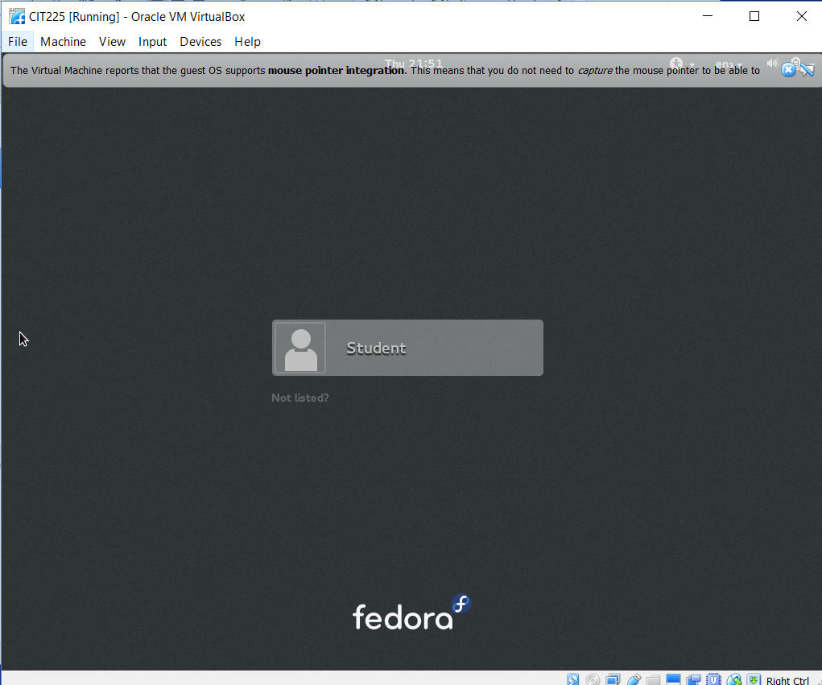
7. If you see this, then your VM is up and running. Good Job!
8. Use the passwords listed above to login.
9. --

#EOF